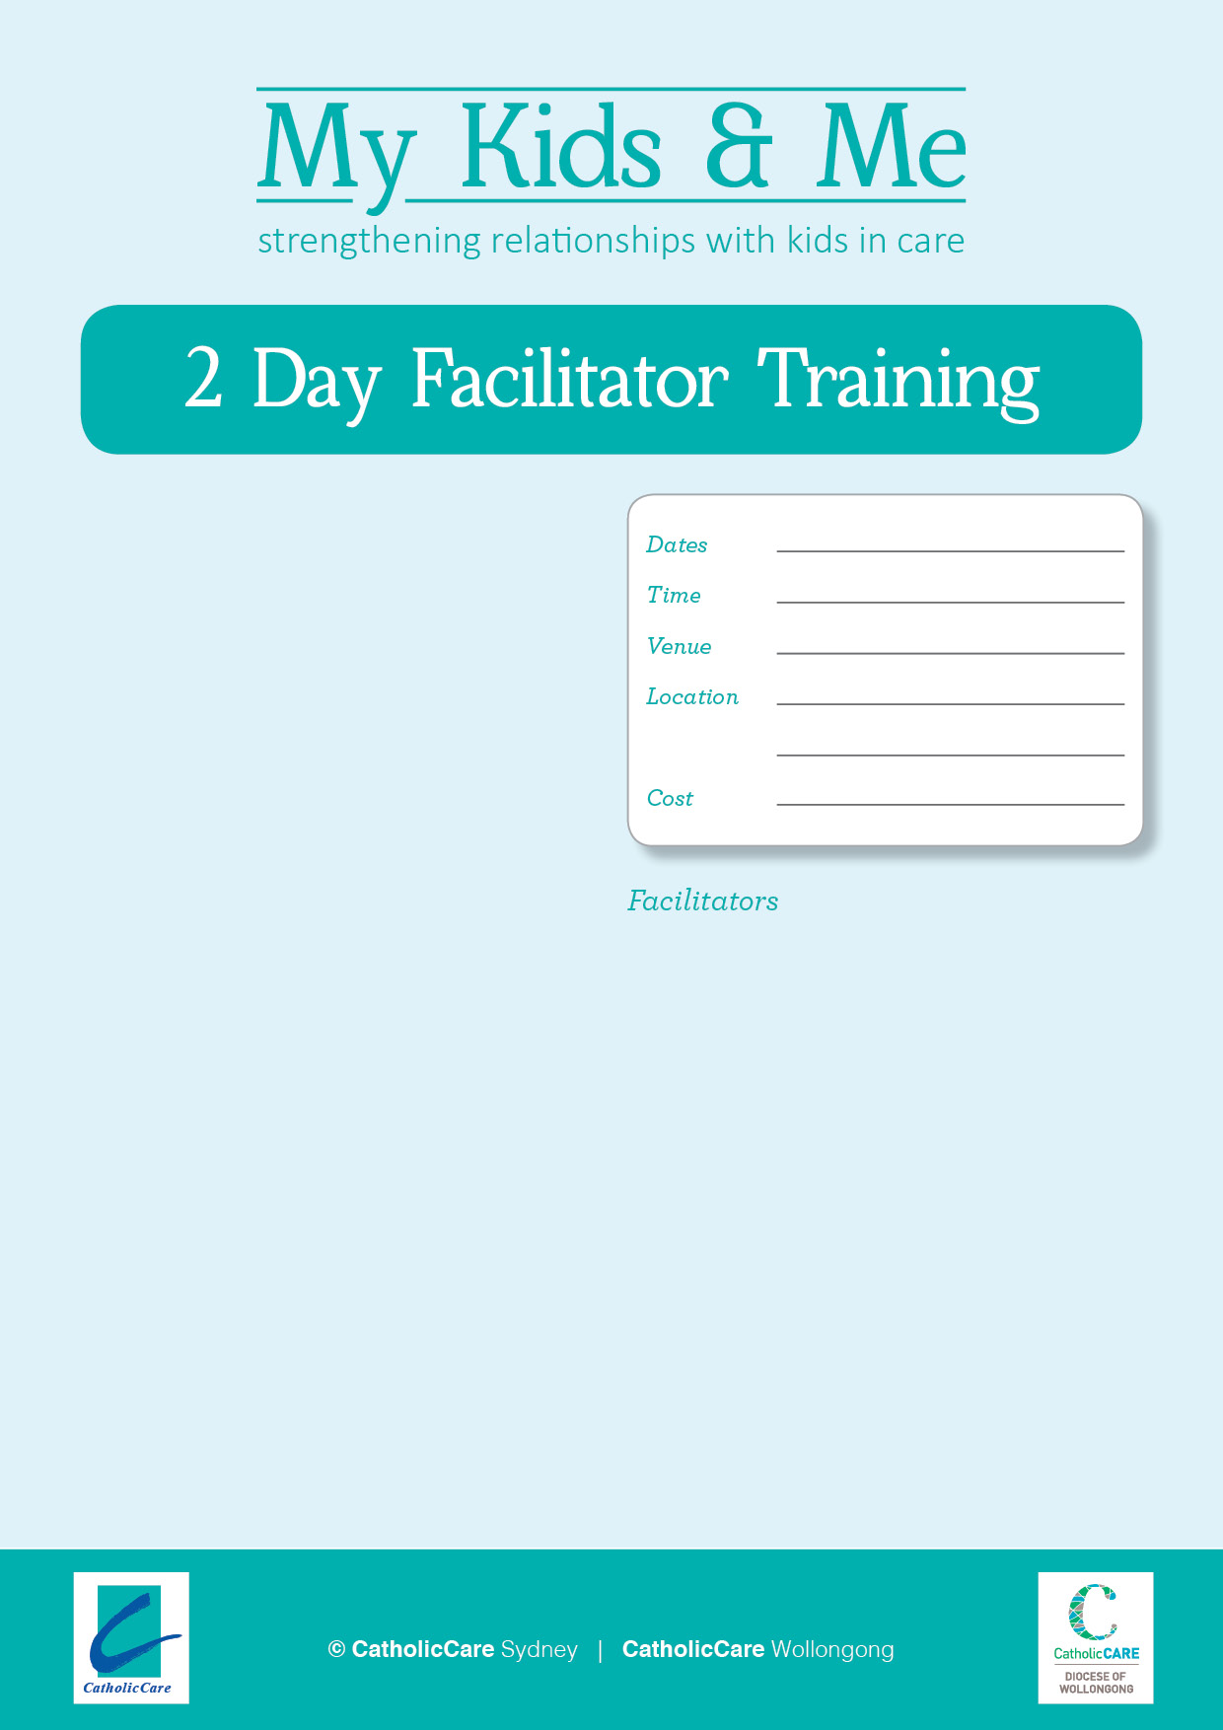­­

$550

Lewisham NSW 2049

Cnr Thomas and West Streets

12th and 13th December 2018

My Kids and Me is a unique seven week course for parents whose children have been removed into statutory care. Restoration may or may not be part of the case plan. The aim of the program is to give parents an opportunity to reflect on their experiences and provide an opportunity for change. The course is psycho-educational in nature and was developed by a team of parent educators, psychologists, social workers and intensive family support workers. The My Kids and Me program was developed by CatholicCare Sydney and CatholicCare Wollongong between 2008 and 2011. It was externally evaluated in 2011 by the Centre for Child Protection, University of South Australia. Copies of the evaluation are available from the developers. In 2015 the program was awarded Gold Accreditation by the Institute of Group Leaders. The program won the 2015 CSSA award for most innovative new program and was nominated for the 2015 HESTA Community Sector Organisation Award.

The two day Facilitator Training Program is aimed at experienced workers in the areas of parent education, out of home care, intensive family support or related services. It would be expected that these staff would have tertiary qualifications in the social sciences or equivalent. They should have knowledge and experience of group process and theory and preferably have completed training in group facilitation. Facilitators should have an understanding of the issues related to parents whose children have been removed, the capacity to manage strong emotions, a willingness to use creative tools and the ability to work in a co-facilitation model. Organisations should note that two trained facilitators are required to lead the My Kids and Me course. Facilitators may be required to sign a licensing agreement.

­

**Angharad Candlin** is the Manager of CatholicCare Sydney’s Parent Education program. She is a Psychologist with over 25 years’ experience working with families, including out of home care and adoption. Angharad regularly facilitates parenting groups as well as training, supervising and mentoring other professionals. Angharad has led the My Kids and Me development and training team since 2008.

**Monique Dickerson** is a Parent Educator with CatholicCare Sydney, working in South West Sydney. Monique’s background is in Adult Education and she has worked in this area for over 15 years. Monique regularly facilitates My Kids and Me and other parenting courses with groups which have people from multiple cultural and language groups and areas of vulnerability.

*The My Kids and Me course is highly creative and utilises numerous resources. The cost of training includes one kit per facilitator. Kits include a Facilitator guide, posters and enough participant resources for one group. Additional participant material is available to be purchased at a small cost. For further information contact the Co-ordinator Parent Education, CatholicCare Sydney 9509 1111.

9am - 5pm

CatholicCare